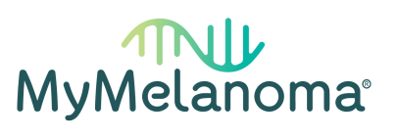The MyMelanoma Research Study
MyMelanoma is a partnership between people who have been affected by melanoma, clinicians and researchers to form the largest melanoma research study in the world.
MyMelanoma is designed to answer the most important unanswered questions in melanoma research.
MyMelanoma is open to anyone who has ever been diagnosed with a melanoma of the skin, of the mucosal surfaces (e.g. nose, genitals) or under the nails.
Will you join us?
To sign up to be part of MyMelanoma or if you have any questions for us, please visit our website:
www.mymelanomastudy.org
Or scan our QR code below.
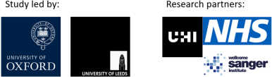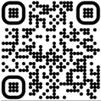IRAS 298521 Poster, version 1, 23.08.22

